BACHELOR OF SCIENCE

MATHEMATICS

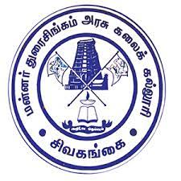

DEPARTMENT OF MATHEMATICS

Raja Doraisingam Govt Arts & Science college

SIVAGANGA-630553

### IRevolution: A Data-Driven Exploration Of Apple's IPhone Impact In India

TeamMates :

P. Vaishnavi : 0321121026

K. Kanchanadevi : 0321121007

V. Vinothini : 0321121027

M. Elammal : 0321121005

Guided by

K. JEYAPAL